EDIFY E-LEARNING PROJECT
MIDDLE & TOP CLASS END OF PROGRAM ASSESSMENT
SUBJECT: READING
DURATION: 1 hour
My name is_______________________
1. Read “a” syllables
ba ca da fa ga ha ja ka la ma na pa ra sa ta va wa ya za
Write the syllable for the picture

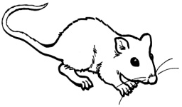___ 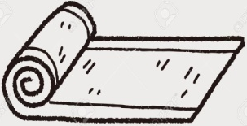___ 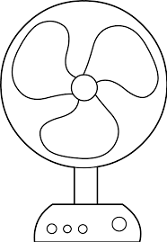___

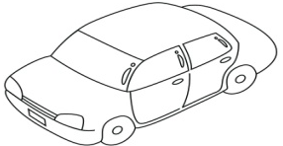___ 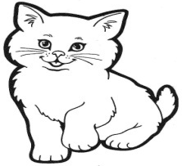___ 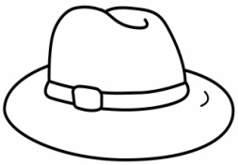___

- Fill in with a syllable and read
it is a ___ m 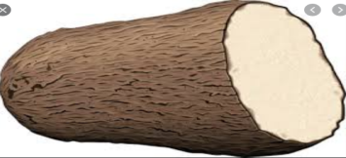

it is a ___p 

it is a ___n 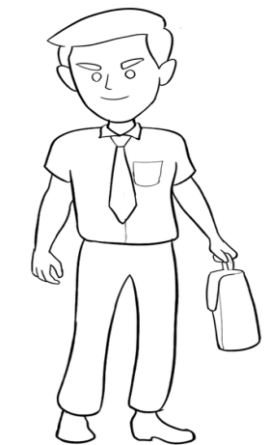

Good luck!

